Table of Contents

1.0.0 Required Engineering Deliverables 1

2.0.0 Design Requirements 1

3.0.0 Preparations 5

4.0.0 Product Design Requirement (PRD) 5

5.0.0 Schematic (SCH) 5

6.0.0 Printed Circuit Board (PCB) 6

6.1.0 Component Choice and Placement 6

6.2.0 Design Rule Check 6

## Required Engineering Deliverables

* 1. Product Requirements Document (PRD) conforming to LB standards as described in this document. Template PRDs are provided by LB (**HDK-hardware-dev-manual/Design/Templates for PRD**).
  2. Schematic Diagram (SCH) conforming to LB standards as described in this document. Template SCHs are provided by LB in the **HDK-eagle-templates-libraries/Eagle Templates for SCH and BRD** folder of the HDK.
  3. PCB Layout (PCB) conforming to LB standards as described in this document. Template PCBs are provided by LB in the **HDK-eagle-templates-libraries/Eagle Templates for SCH and BRD** folder of the HDK.

## Design Requirements

* 1. System Parameters:  
     VCC = 5VDC  
     BitSnap connector max current = 1A  
     Nominal temperature range = 10C to 40C
  2. Female bitSnap connector pinout:  
     Pin 1: GND (ground, 0VDC)  
     Pin 2: SIG (signal, 0 to 5 V continuous)  
     Pin 3: VCC (power, 5VDC)
  3. Male bitSnap connector pinout:  
     Pin 1: VCC (power, 5VDC)  
     Pin 2: SIG (signal, 0 to 5 V continuous)  
     Pin 3: GND (ground, 0VDC)

## 

Figure 1: Male and female bitSnap™ connector pinouts

* 1. All inputs must be high impedance. The preferred input impedance must be equal to or greater than 1 MΩ (megOhm).

## 

Figure 2: Example of an input stage, included in the Eagle templates

* 1. All outputs must be low impedance, with symmetric drive characteristics (yields same performance when either sinking or sourcing current.) The output impedance must be less than 100 ohms.

## 

## Figure 3: Example of an output stage, included in the Eagle templates

* 1. All ICs must have at least one 0.1 uF bypass capacitor on every IC power supply.

* 1. There must be a series ferrite bead between all circuitry and bitSnap Vcc connections (see Figure 4).

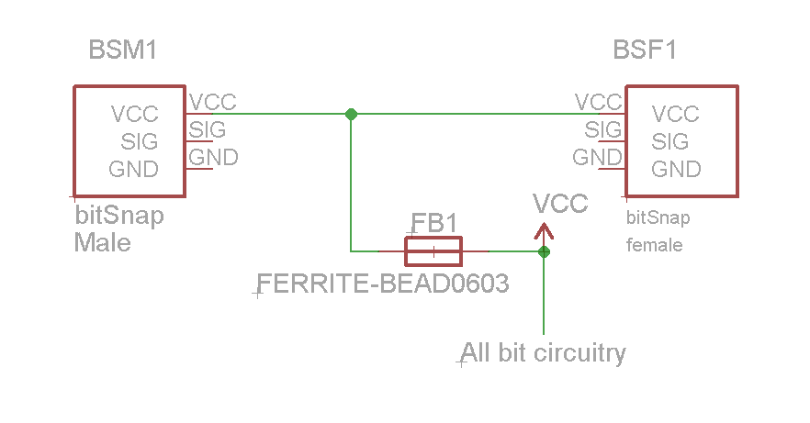

Figure 4: Required topology of Vcc connection

* 1. Inputs: Every bitSnap input must have a series 10K current limiting resistor on the SIG line (see Figure 2).
  2. Inputs: Every bitSnap input must have a shunt TVS diode, or equivalent ESD countermeasures (see Figure 2).
  3. Inputs: Floating bitSnap inputs are **not** permitted.
  4. Preferred Parts. littleBits recommends the use of specific part numbers for typical functions such as opamps, switches, potentiometers, and others. A list of these preferred parts can be found in HDK-eagle-templates-libraries/libraries/lbPreferredParts.xlsx. SMD components are preferred over through-hole and the 0603 footprint is preferred for passive components.

## Preparations

* 1. Download and install the following from the HDK-eagle-templates-libraries repository

Parts Libraries:

libraries/LITTLEBITS140915.lbr

Design Rules Files:

libraries/littleBitsDRC_140813.dru //for 2-layer boards

libraries/littleBits4-LAYERDRC_140813.dru //for 4-layer boards

## Product Design Requirement (PRD)

* 1. The PRD should be created by the developer from the template provided by LB. The template is available in Design/Templates for PRD/prd_template.xls. A copy of the template will be provided by LB in the module repo if the project is accepted.

## Schematic (SCH)

* 1. The schematic should be based on one of the SCH templates provided by LB, found in **Design/Eagle Templates for SCH and BRD**.
  2. Schematic grid must be set to 0.1 inch.

## Printed Circuit Board (PCB)

* 1. Set the PCB layout primary grid to 0.05mm. Set the alternate grid to 0.01mm.

### Component Choice and Placement

* + - 1. bitSnap connectors must not be moved from their original positions in the templates.

### Design Rule Check

* + - 1. Board layouts must be verified using the littleBits DRC file provided.
      2. The DRC file must be run with only layers 1 to 20 turned on.
      3. Width error of revision number copper text can be ignored.